Health & Safety
Risk Assessment

About the Risk Assessment
Activity or Workplace Assessed: | Schools reopening during Coronavirus pandemic – Infection Control, Hygiene and Social Distancing  Click here to enter text.  Click here to enter text. | Location/  Department: | Ysgol Gyfun Gwent Is Coed  Click here to enter text.  Click here to enter text.
Persons Consulted/  Involved in Risk Assessment | SLT Ysgol Gyfun Gwent is Coed  Governing Body | Risk Assessment Reference Number: | 002
Date of Assessment: | 18/08/2020 | Next Review Date: | Click here to enter a date.

Hazard and potential injury | Persons Affected | Existing Control Measures | Risk rating |  |  | Further action required | Risk rating |  |  | Action by: | Due date: | Completion date:
 |  |  | L | S | RR |  | L | S | RR
Contracting Coronavirus – classroom set up, resources and activities | All pupils and staff on site | Staff all aware of social distancing rules | 4 | 4 | 16 | Contact groups to be kept as small as possible in line with WG guidance. Contact groups to be set up per school year.  Records to be kept of anyone not normally in a contact group who comes into it e.g. specialist interventions, to support Test Trace Protect (TTP) should it be needed.  Contact groups to be allocated specific rooms in different areas of the school.  So far as possible, pupils to remain in one classroom.  Pupil movement between these classes will be  minimal with teachers moving form class to  class.  Seating to be arranged with desks and chairs facing the front of the class. These will be arranged with as much space as possible between them.  Teachers will be at the front of the class keeping a distance of at least 2 metres between themselves and the learners.  Staff to maintain, as far as possible, 2m distance from other staff and pupils.  Staff seating to be arranged so as to maintain 2m distance from other adults in room.  Staff to maintain, so far as possible, 2m distance from pupils. It is acknowledged that this will not always be possible.  Staff to ensure that specific interactions which break social distancing with children occur as briefly and infrequently as possible.  Activities to be planned so as to discourage close or regular contact between individuals, staff and pupils, or the sharing of resources.  Pupils to bring their own writing materials in order to minimise the sharing of resources.  Resources to be cleaned between users on different days (including computer keyboards/mouse devices).  Children to be discouraged from engaging in games or interactions that require physical proximity or contact.  Windows to be opened where possible.  Consideration to be given to maximising use of outdoor space for learning and play  Children to be given age appropriate information regarding the need for social distancing and the new school rules.  Signage to be displayed to reinforce messages. | 2 | 4 | 8 | HT  All teachers  All Teaching Assistants  All SSO staff  Onsite Cleaner | Daily with at least 3 periodic checks each day | Ongoing – as and when necessary
Contracting Coronavirus – hygiene, handwashing | All pupils and staff on site | All staff aware of government guidance on handwashing | 3 | 4 | 12 | All staff to wash their hands when they arrive on site.  All children to be taken to wash their hands when they arrive on site.  All staff and children to wash their hands before and after eating.  All hand washing to be done in line with public health and NHS guidance.  Handwashing to be encouraged as often as possible during the school day.  Hand Sanitiser and equipment wipe stations to be placed in every room and at every entry and exit points within the building.  Hand Sanitiser and equipment wipe stations to be placed at the water fountains.  Resources for hygiene stations to be replenished when needed to ensure availability | 2 | 4 | 8 | All staff and pupils | As described daily | Ongoing – as and when necessary
Contracting Coronavirus – hygiene, toilets | All staff and pupils | Schools have comprehensive cleaning regime | 3 | 4 | 12 | Focused Periodic Cleaning to take place every day – service provided by Norse.  All desks, work stations, should be wiped down with disinfectant after use and/or between activities and at the end of the day.  A supply of disinfectant sprays and wipes for every room being used during this period (these should be replenished when required),  Door handles, window handles and surfaces in communal areas to be wiped down with disinfectant at frequent intervals during the day.  Toilets to be cleaned frequently and systematically – following NCC guidance.  Cleaner on site to ensure systematic cleaning throughout day.  First Aid staff to follow NCC guidelines regarding PPE required for various accidents.  All staff to use their own dishes and cutlery and to wash their own dishes.  All used paper towels to be disposed of using NCC guidelines.  Toilets to be cleaned frequently and thoroughly, but not necessarily after every use.  Most contact groups to use separate toilets. Years 7 and 10 will have to use the same facilities  with hand sanitisers provided to be used before entering.  Strong focus and messaging in all toilets to encourage good and effective handwashing. | 2 | 4 | 8 | HT  All teachers  All Teaching Assistants  All SSO staff  Onsite Cleaner | Daily with at least 3 periodic checks each day. | Ongoing – as and when necessary
Contracting Coronavirus – body fluid spills | All staff and pupils | Schools have comprehensive cleaning regime | 3 | 4 | 12 | Spillage packs on site to immediately deal with any bodily fluid spills. Bodily fluid spills must not be left for cleaners later. | 2 | 4 | 8 | HT  All teachers  All Teaching Assistants  All SSO staff | At time of spillage | Ongoing – as and when necessary
Contracting Coronavirus – illness | All Staff and Pupils | All staff aware of government guidance on self-isolation | 3 | 4 | 12 | All staff to be vigilant to their own health and to follow latest government guidance on self-isolation if they or their family are displaying symptoms or they are informed by the track and trace service that they have been in contact with a confirmed case.  National guidance around staying at home if they are displaying symptoms to be reiterated to pupils (where age appropriate) and parents/carers.  All staff to be vigilant to the health of their pupils and ensure they are following latest national guidance if a pupil appears to be unwell.  Conference room to be designated for isolation should pupils or staff members become ill, in line with national guidance.  All staff to be made aware of the area designated for isolation within the school if a pupil/staff member develops symptoms whilst on site.  In the event of a confirmed case of covid-19, instructions from TTP team to be followed with regards to contact group self isolation etc. NCC Education and Health and Safety Teams to be informed. | 2 | 4 | 8 | HT  All teachers  All Teaching Assistants  All SSO staff  Onsite Cleaner | 01/09/2020 | Ongoing – as and when necessary
Contracting Coronavirus – PPE Mainstream, SEN | All staff and pupils | Staff all aware of social distancing rules  In line with government guidance no additional PPE is necessary for routine activities | 4 | 4 | 16 | Additional PPE provided for first aid and use with symptomatic children.  Keep under review whether support for any individual child (e.g. following vulnerable and statemented children risk assessment completion) requires further consideration of PPE risk control measures and individual assessment – contact health and safety for support.  Where there are specific risks, which might include serious underlying health conditions, lack of ability to understand social distancing concepts, inability to tell people if they are feeling unwell and behaviour which may increase the risk of transfer of bodily fluids, including during personal care, additional PPE (type II masks and face protection) may be required, following an individual risk assessment for that child. | 2 | 4 | 8 | HT  All teachers  All Teaching Assistants  All SSO staff | As described daily | Ongoing – as and when necessary
Contracting Coronavirus – Social Distancing outside of the classroom | All staff and pupils | Staff all aware of social distancing rules | 3 | 4 | 12 | A one-way system will operate in the corridors and at entrance and exit points. A distance of 2m will be marked out in these areas including outside the toilets.  Pupils, staff and visitors will have to wear face coverings in all communal areas including reception, corridors, toilets, stairwells, canteen.  Break and lunchtimes will be staggered. Year 7 and 8 pupils will have their break 9.50am – 10.10am with lunch between 12.10pm – 13.00pm. Years 9, 10 and 11 will have their break 10.50am – 11.10am with lunch between 13.10pm and 14.00pm.  Pupils in different contact groups will have access to specific outside areas during break and lunchtimes.  Year 7 – front of school  Year 8 – yard  Year 9 – front of school  Year 10 – yard  Year 11 – area surrounding temporary units  Outside areas to be supervised by staff at all times to discourage physical contact between individuals in the same contact group. | 2 | 4 | 8 | HT  All teachers  All Teaching Assistants  All SSO staff | As described daily from 3/09/20 | Ongoing – as and when necessary
Contracting Coronavirus - Staff Welfare Facilities | All pupils and staff on site | Staff all aware of social distancing rules | 4 | 4 | 16 | Seating in staff resting areas to be positioned so as to maintain 2m social distancing.  Communal equipment such as kettles and microwaves to be taken out of use.  Staff fridges to remain in use and be added to cleaning schedule.  Staff to bring in all food and drink necessary for the day.  All cups, plates, cutlery etc. to be taken home by staff at the end of the day. | 2 | 4 | 8 | HT  All teachers  All Teaching Assistants  All SSO staff | As described daily from 1/09/20 | Ongoing – as and when necessary
Contracting Coronavirus – pupils eating and drinking | All pupils and staff on site | All staff aware of government guidance | 4 | 4 | 16 | Staff to bring in any food necessary for the day for the first two weeks.  Children to bring a packed lunch for the first two weeks and eat during their scheduled break and lunchtime in their designated outside or inside area.  Grab bags will be provided for eFSM learners.  From September the 14th children to eat and drink in dining hall on staggered schedule. All eating areas to be wiped down thoroughly before and after eating, using normal household cleaning products.  Water bottles can be refilled by children (where they are able) or staff, using proper hand hygiene processes before and after. | 2 | 4 | 8 | HT  All teachers  All Teaching Assistants  All SSO staff | As described daily from 1/09/20 | Ongoing – as and when necessary
Contracting Coronavirus – First Aid Provision | All pupils and staff on site | All staff aware of government guidance | 3 | 4 | 12 | Review of First Aid needs assessed based on number of people likely to be on site at any time.  First aiders to consider what low level interventions pupils may be able to manage for themselves so as to maintain social distancing as far as possible e.g. older pupils could use a cold compress on a leg or arm.  Additional PPE (masks, gloves, visors, aprons) in place (via central order and cluster distribution) for first aid interventions that require close contact, particularly where examination or treatment of face, mouth or head is required e.g. managing bleeding from a head wound or where the spray of bodily fluids is likely e.g. child vomiting | 2 | 4 | 8 | HT  All teachers  All Teaching Assistants  All SSO staff | As described daily from 1/09/20 | Ongoing – as and when necessary
Contracting Corona Virus – Corridors and circulation areas | All pupils and staff on site | Staff all aware of social distancing rules | 4 | 4 | 16 | Corridors and circulation areas assessed for pinch points, passing places, and areas of high volume usage.  Corridors signed to ensure one-way travel through the school building.  Pupils to be given clear instructions regarding corridor/circulation area behaviour and social distancing.  Pupils, staff and visitors will have to wear face coverings in all indoor communal areas including reception, corridors, toilets, stairwells, canteen.  Minimise number of children in corridors and circulation areas at any time by the use of the following control measures;  - One way system  - Keep Left/Keep Right  - Staggered breaks  - Pupils to remain in the same area throughout the day  - Teachers to move from class to class  - Supervised movement at the beginning of the day, during break and at the end of the day | 2 | 4 | 8 | HT  All teachers  All Teaching Assistants  All SSO staff | As described daily from 1/09/20 | Ongoing – as and when necessary
Contracting Corona Virus – Access and Egress, Drop Off and Pick Up | All pupils and staff on site | Staff all aware of social distancing rules | 4 | 4 | 16 | Social distancing markers to be used from the car park to the school entrance.  Parents to wear face coverings when visiting school, and at drop-off and collection areas. Maintaining clear social distance at the school gates will also reduce risk and set a good example to pupils.  Parents should exit the car park as soon as they have dropped off to maintain a steady flow through the car park.  Staff to supervise between the car park and entrance during Drop Off and Pick Up.  Pupils to be guided to their registration classes as soon as they arrive in school.  At the end of the school day pupils will leave their classes within their designated areas a room at a time.  All parents to wait for their children in their car in the car park.  All waiting areas for parents to be outside.  Parents to be given clear instructions around start and finish times.  Clear instructions to be given to parents and children around use of home to school transport and expectations around behaviour. | 2 | 4 | 8 | HT  All teachers  All Teaching Assistants  All SSO staff | As described daily from 3/09/20 | Ongoing – as and when necessary
Contracting Corona Virus – School Transport | Pupils accessing school transport | None | 4 | 4 | 16 | Pupils over the age of 11 will be expected to wear face coverings on school transport.  All pupils to be directed to sanitise their hands at the end of the day before putting on masks to get on transport.  Regular messaging to pupils regarding safe storage of used re-useable masks and to wear a clean one for each journey.  See Home to School Transport risk assessment for further guidance | 2 | 2 | 8 | HT  All teachers  All Teaching Assistants  Parents | As described daily from 3/09/20 | Ongoing – as and when necessary
Contracting Corona Virus – school offices | All pupils and staff on site | Staff all aware of social distancing rules | 4 | 4 | 16 | Social distancing to be maintained in school offices - furniture to be removed or taken out of use where necessary.  Windows to be kept open at all times where possible.  Staff provided with their own keyboard, mouse and phone and these should be cleaned regularly. | 2 | 4 | 8 | HT  All SSO staff | As described daily from 1/09/20 | Ongoing – as and when necessary
Contracting Coronavirus – illness in higher vulnerability individuals | All staff and pupils in the government’s predefined list of people at higher risk | Staff all aware of social distancing rules | 4 | 4 | 16 | Specific Welsh Government guidance and individual risk assessment in place for staff to complete. Any staff considered vulnerable to covid-19 must complete this and discuss the results with their line manager. If any staff member scores in the 4-6 range they, and their line manager, must complete the supplementary form to establish whether a safe return to school can be managed.  In line with WG guidance and risk assessment toolkit, staff who were previously shielding only to be in the workplace where they can manage strict social distancing.  Any child in the higher risk category attending school will have a personal risk assessment/asthma card/care plan to cover their personal circumstances. This to be agreed with parents/carers.  All staff working in the school to be made aware of the child’s medical needs and be vigilant to any signs of illness. | 2 | 4 | 8 | HT  All teachers  All Teaching Assistants  All SSO staff | Prior to 1/09/20 | Review for September 2020
Returning to the workplace – staff wellbeing* | Staff have access to Carefirst EAP | Staff all aware of government guidance | 3 | 4 | 12 | Carefirst details to be redistributed to staff:  Care First  Free access to confidential advice and supportline 24 hours a day, 365 days a year.  0800 174319  365 days a year 24 hours a day, 7 days a week.  www.carefirst-lifestyle.co.uk  Care First login for NCC employees:  Username: newcc001  Password: wellbeing  Staff considered to be vulnerable to have individual assessment. | 2 | 4 | 8 | HT  All teachers  All Teaching Assistants  All SSO staff | Prior to 1/09/20 | Review for September 2020
Contracting Coronavirus – breaks, lunchtime and use of shared play equipment | Pupils on site | Staff all aware of government guidance | 3 | 4 | 12 | Games involving close physical contact to be discouraged  Games involving shared play equipment to be discouraged  Shared outdoor play equipment to be cleaned frequently. Avoid use of resources that cannot be easily cleaned such as sand pits.  Breaktimes/lunchtimes to be staggered/zoned to minimise contact groups mixing (see above). | 2 | 4 | 8 | HT  All teachers  All Teaching Assistants  All SSO staff  All lunchtime supervisors | As described daily from 3/09/20 | Ongoing – as and when necessary
Posters and Messaging – ensuring that the right information is disseminated | All pupils and staff on site | Staff all aware of social distancing rules | 3 | 4 | 12 | Appropriate posters to be placed in strategic locations around the school  information distributed via school messaging systems/social media/website  Anyone who needs support in sourcing signage should contact health and safety or procurement | 2 | 4 | 8 | HT  All teachers  All Teaching Assistants  All SSO staff | Prior to 1/09/20 | Review for September 2020
Social Distancing – Emergencies | All pupils and staff on site | Staff all aware of social distancing rules | 3 | 4 | 12 | Emergency procedures (such as fire plans) to be revised to take account of social distancing requirements where possible. | 2 | 4 | 8 | HT  All teachers  All Teaching Assistants  All SSO staff | Prior to 1/09/20 | Review for September 2020
Contracting Corona Virus - visitors on site | All pupils and staff on site | Visitors aware of social distancing rules | 3 | 4 | 12 | Only essential visitors are allowed on site e.g. supply teachers, safeguarding professionals, social workers, police officers, careers officer.  All visitors to fill in the TTP form.  All visitors to abide by the school’s risk assessment and the measures put in place to ensure social distancing and reduce possible transmission of virus including the wearing of face coverings in communal areas (see above).  Visitors to adhere to their own institution’s risk assessment if applicable.  All visitors to be allocated their own room as far as possible. | 2 | 4 | 8 | All visitors | As described daily | Ongoing – as and when necessary
Visitors to be responsible for cleaning and disinfecting their rooms in between working with different pupils.

Social distancing measures to be put in place in their rooms.
Contracting Corona Virus – vulnerable pupils form years 9, 10 and 11 on site during firebreak (2/11/20 – 6/11/20) | All pupils and staff on site | Staff all aware of social distancing rules | 3 | 4 | 12 | Pupils to be socially distanced between contact groups in an IT room.  Pupils to use the same IT equipment in the same position within the room for the week.  Pupils to be supervised at all times.  Pupils to be encouraged to wash their hands thoroughly on a regular basis and to keep their workstations clean.  Pupils to follow the one-way system.  Pupils to wear face coverings in all communal areas.  Break and lunchtimes will be staggered. Year 7 and 8 pupils will have their break 9.50am – 10.10am with lunch between 12.10pm – 13.00pm. Vulnerable pupils in years 9, 10 and 11 will have their break 10.50am – 11.10am with lunch between 13.10pm and 14.00pm. | 2 | 4 | 8 | HT  All teachers  All Teaching Assistants  All SSO staff | 2/11/20 | 6/11/20

Name of Risk Assessment Reviewing Manager: | Eirian Jones (Headteacher) Elin Maher (Chair of Governors)
Date Reviewed  4-09-20 | 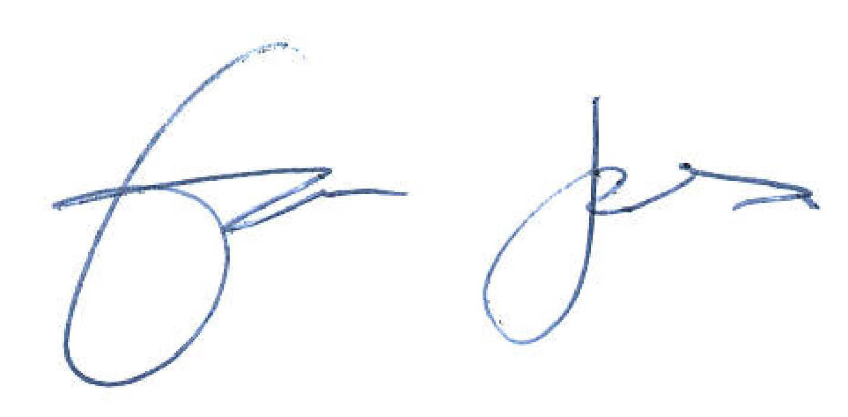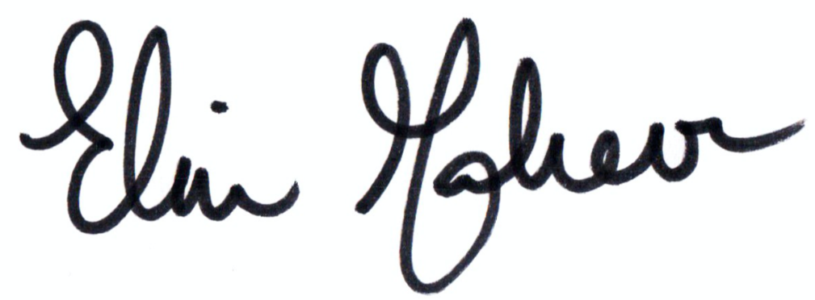

School Protocols | If already documented elsewhere please refer to where this kept/link below
School Rota/Timetable
Toilet Breaks
Social Distancing Outside the Classroom (list activities to be undertaken and describe briefly social distancing measures) | Hall: | Gym: | Playground:
Cleaning Schedule including toilets
Corridors and Circulation Areas – signage and social distancing markers

For premises related issues, including managing fire safety, please see the School Premises Recovery Checklist.

*Pupil welfare issues, safeguarding, curriculum and organisation of learning, staffing ratios and rotas not dealt with as part of this assessment and will be managed as part of the wider recovery strategy. Vulnerable and statemented learners in standalone assessment.

Useful guidance:

https://gov.wales/keep-education-safe-operational-guidance-schools-and-settings-covid-19

https://phw.nhs.wales/services-and-teams/harp/infection-prevention-and-control/guidance/accordians/docs/infection-prevention-and-control-guidance-2019-for-childcare-settings-0-5-years-in-wales-nurseries-childminding-and-playgroups/

Revision and Amendment Record
Review Date | Amendment Made | Name of Reviewee: | Next Review Date
Click here to enter a date. | Click here to enter text. | Click here to enter text. | Click here to enter a date.
Click here to enter a date. | Click here to enter text. | Click here to enter text. | Click here to enter a date.
Click here to enter a date. | Click here to enter text. | Click here to enter text. | Click here to enter a date.
Click here to enter a date. | Click here to enter text. | Click here to enter text. | Click here to enter a date.
Click here to enter a date. | Click here to enter text. | Click here to enter text. | Click here to enter a date.
Click here to enter a date. | Click here to enter text. | Click here to enter text. | Click here to enter a date.
Click here to enter a date. | Click here to enter text. | Click here to enter text. | Click here to enter a date.

Guide to Likelihood
Level | Descriptor | Description
1 | Rare | This event may occur in exceptional circumstances
2 | Unlikely | Do not expect it to happen but is a foreseeable event.
3 | Likely | The event occurs occasionally
4 | Highly Likely | The event occurs regularly
5 | Frequent | The event occurs frequently

Guide to Severity
Level | Descriptor | Description
1 | No Injury | No injury or adverse outcome
2 | Minor | Short-term injury or illness that is resolved with no medical intervention required
3 | Moderate | Injury or illness which is resolved with medical intervention
4 | Major | Serious injury or illness with results in time-lost and medical intervention
5 | Tragic | Death or long-term / permanent injury or illness.

Likelihood | Severity |  |  |  |  | Suggested timescales
 | 1  No injury | 2  Minor | 3  Moderate | 4  Major | 5  Tragic
1 Rare | 1 | 2 | 3 | 4 | 5 | No Immediate Action
2 Unlikely | 2 | 4 | 6 | 8 | 10 | Action prior to further implementation
3 Likely | 3 | 6 | 9 | 12 | 15 | Urgent Action
4 Highly Likely | 4 | 8 | 12 | 16 | 20
5 Frequent | 5 | 10 | 15 | 20 | 25

